<https://www.strawpoll.me/>

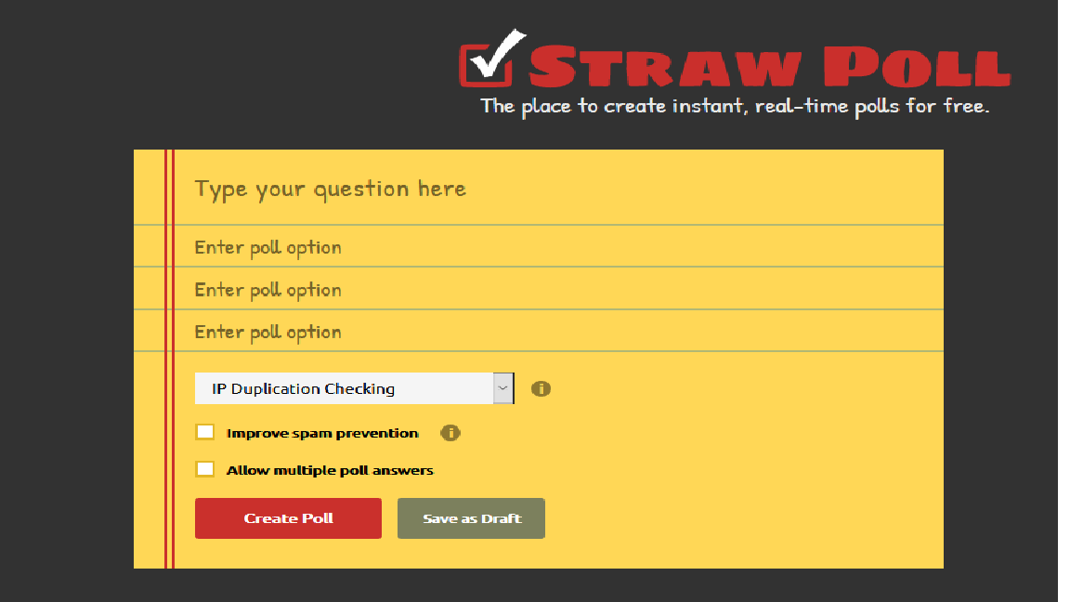

**General use**

It’s to create a poll for private use.

What is a poll?

A poll is a voting tool to get an overview of people’s opinions.

**System requirements**

It’s a web-application, so there is only a browser and an internet connection required.

**Advantages**

* Easy to use and understand
* Fast
* Free
* You can choose several settings
* Account generation is optional
* You can choose the answers in a multiple-choice concept to limit the volume of the outcome

**Disadvantages**

* Once the poll is generated you can’t change it
* You can only register with a twitch account
* The site is not well supported
* The settings can’t cope with all situations (e.g. two users- one connection)
* There is no feedback feature

**Price**

It’s free to use

**Source**

It’s an open source

https://www.strawpoll.me/42731477

https://www.strawpoll.me/42731498